Student Management System using Salesforce Lightning Platform

Introduction
Salesforce is a cloud-based Customer Relationship Management (CRM) platform that allows users to create applications without heavy coding. It provides tools to manage data, automate processes, and generate reports.
In this practical, we developed a Student Management System using Salesforce where we created a custom object, added fields, applied validation rules, inserted records, and generated reports with charts.

Objectives
- To understand Salesforce Lightning interface
- To create and manage custom objects
- To define fields and data types
- To implement validation rules
- To generate reports and dashboards

Theory
Salesforce is a cloud-based CRM platform that allows users to build applications using declarative tools (without coding). It provides features such as:
- Objects → Tables (like database tables)
- Fields → Columns
- Records → Rows
- Validation Rules → Data integrity constraints
- Reports & Dashboards → Data analysis tools
In this experiment, a Student Management System is developed to store and manage student information efficiently.

Practical Implementation
Step 1: Open Salesforce Setup
- Login to Salesforce Developer Edition
- Click on Setup

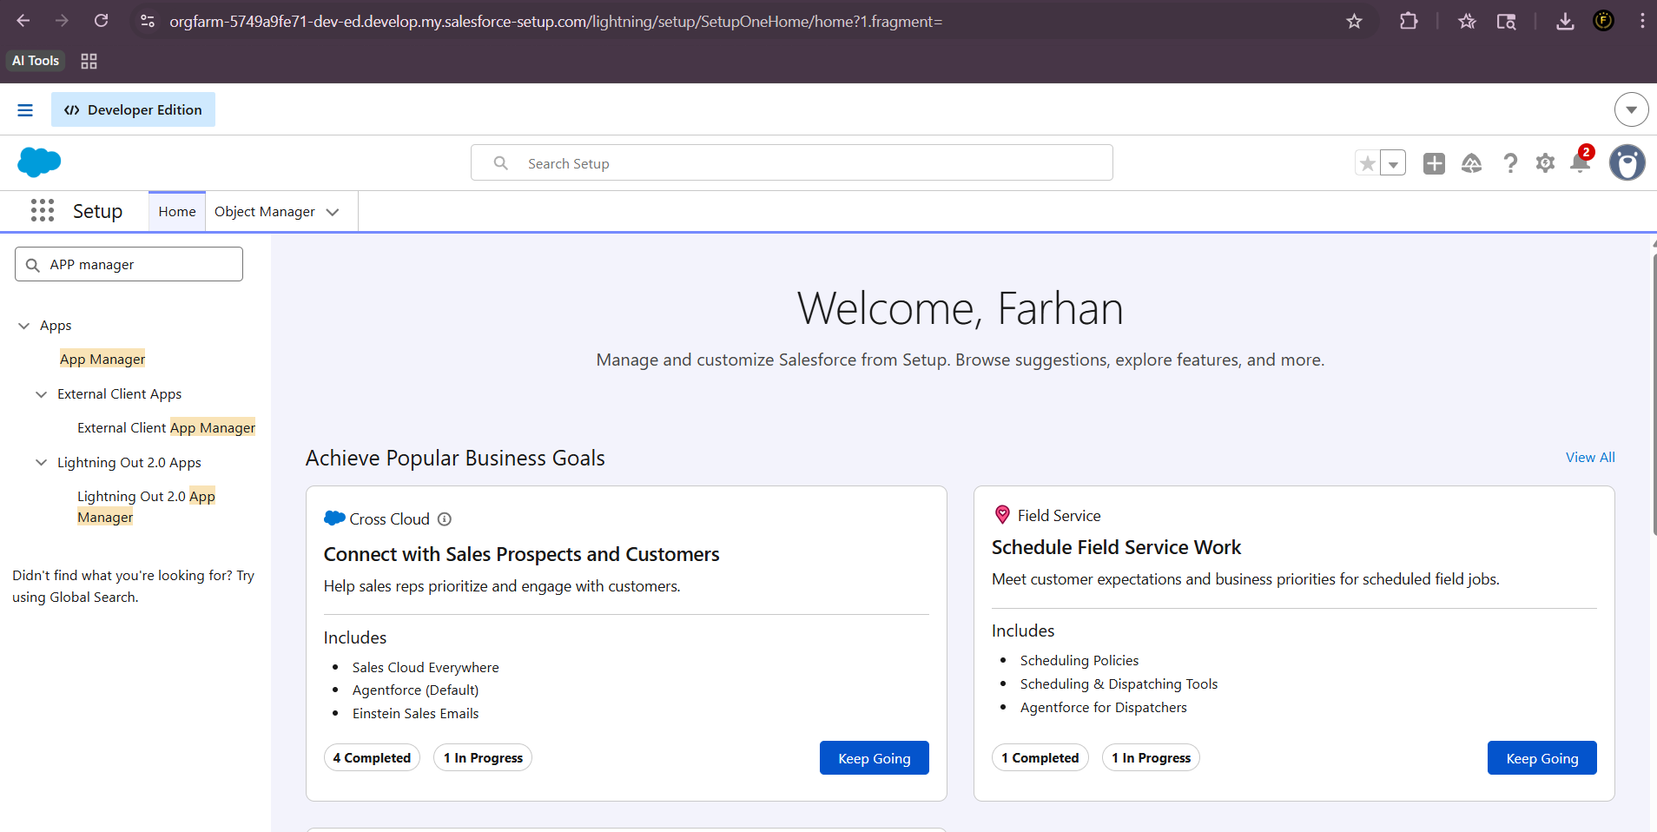
^{Fig 1: Setup Home Screen}
Step 2: Create Custom Object
- Go to Object Manager
- Click New Custom Object
- Enter:
  - Label: Student
  - Plural: Students

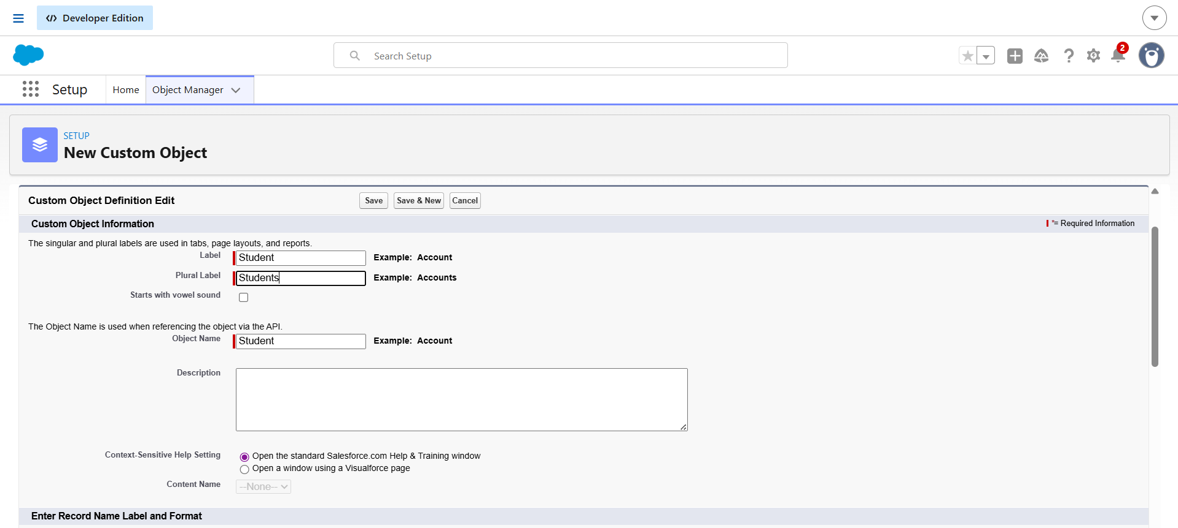
Fig 2: Creating New Custom Object (Student)

Step 3: Viewing Object Details
- Verify object details after creation
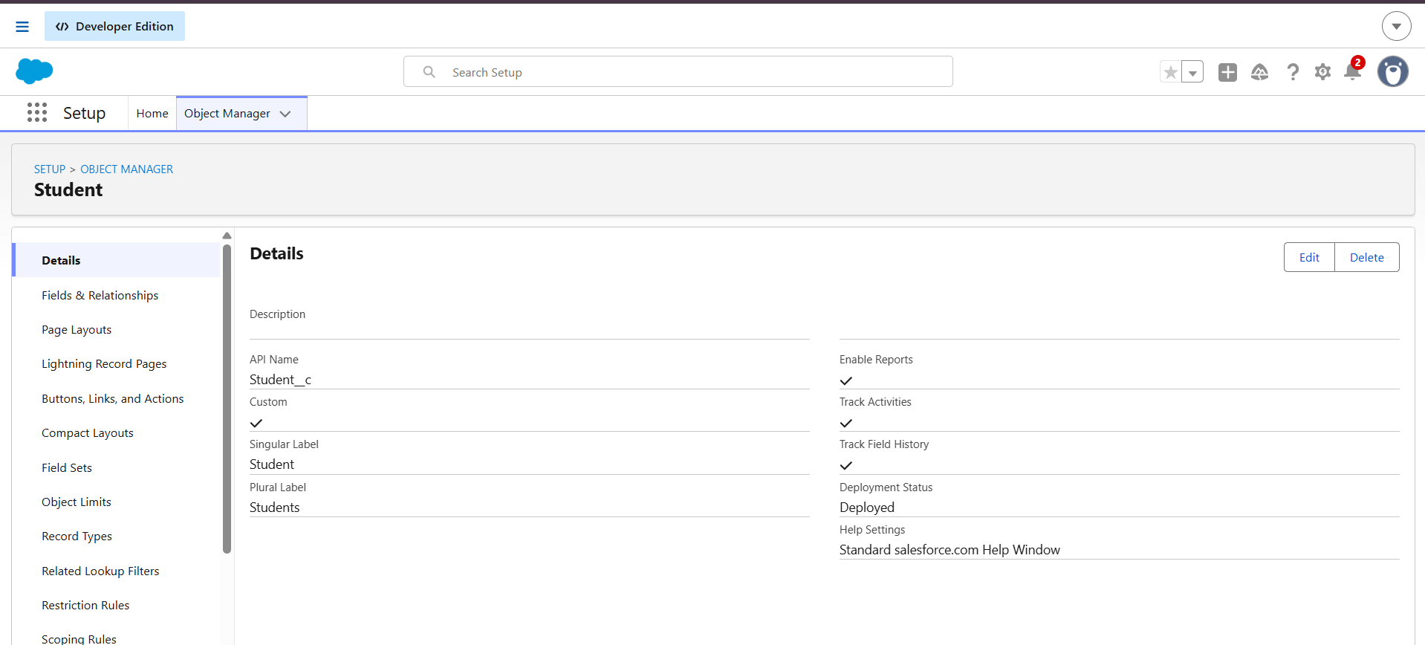
Fig 3: Student Object Details Page
Step 4: Creating Fields
- Age (Number)
- Email (Email)
- Course (Picklist)
- Phone (Phone)
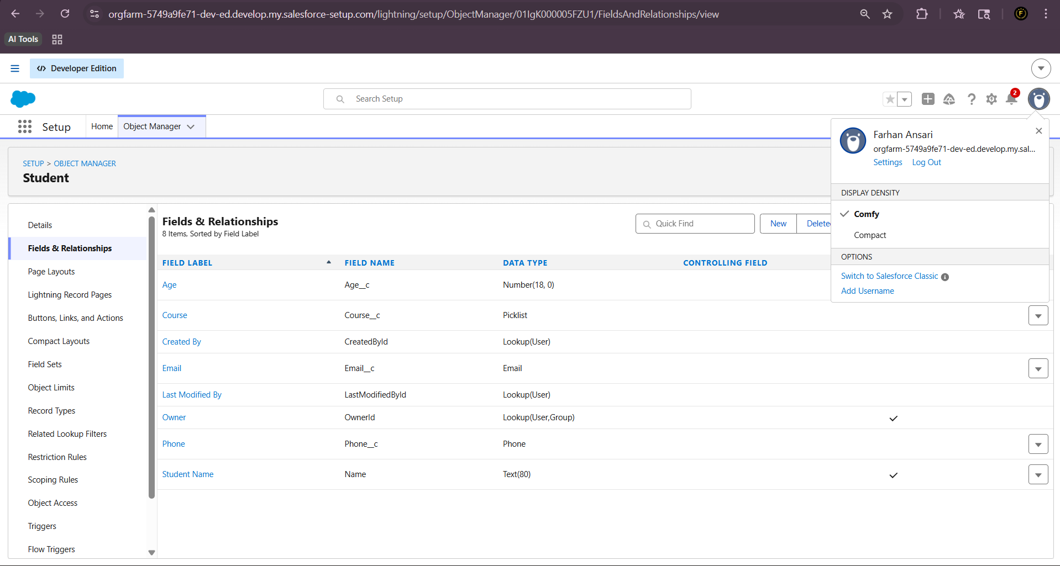
Fig 4: Fields and Relationships Page
Step 5: Creating Tab
- Create tab for Student object
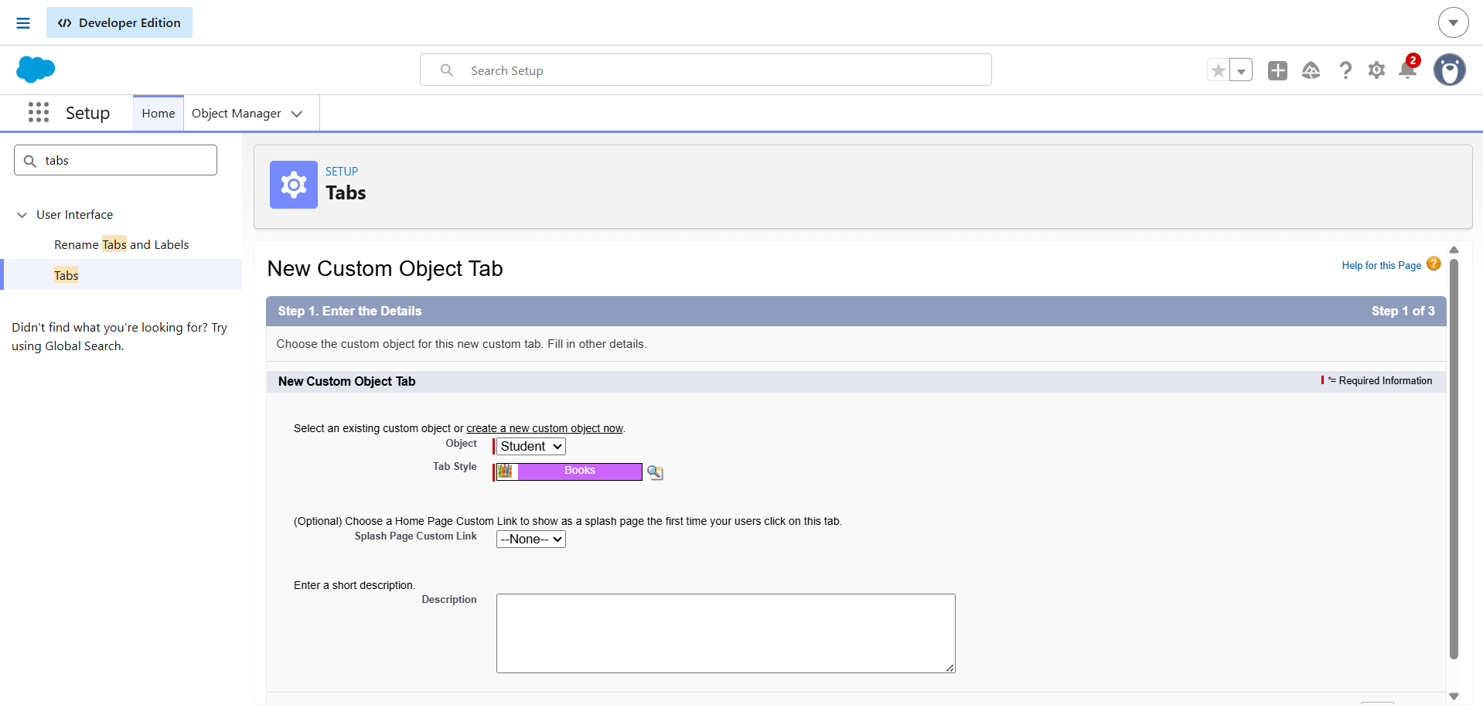
Fig 5: Creating New Field (Age Field Example)

Step 6: Creating Lightning App
- Go to App Manager
- Create new app
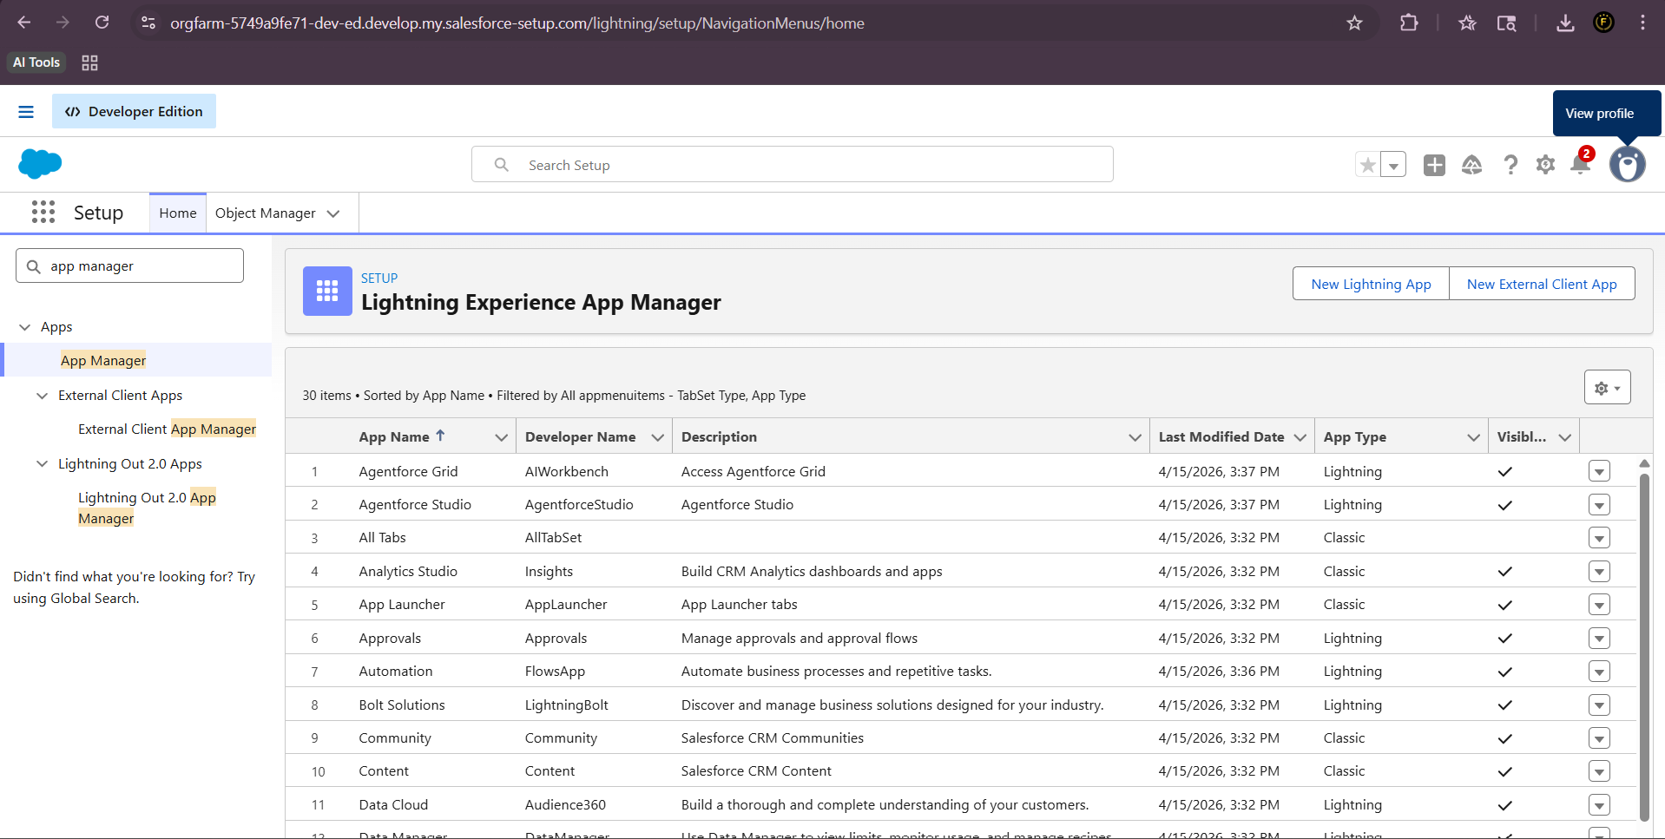
Fig 6: Lightning App Manager Page
Step 7: Adding Records
- Add multiple student records
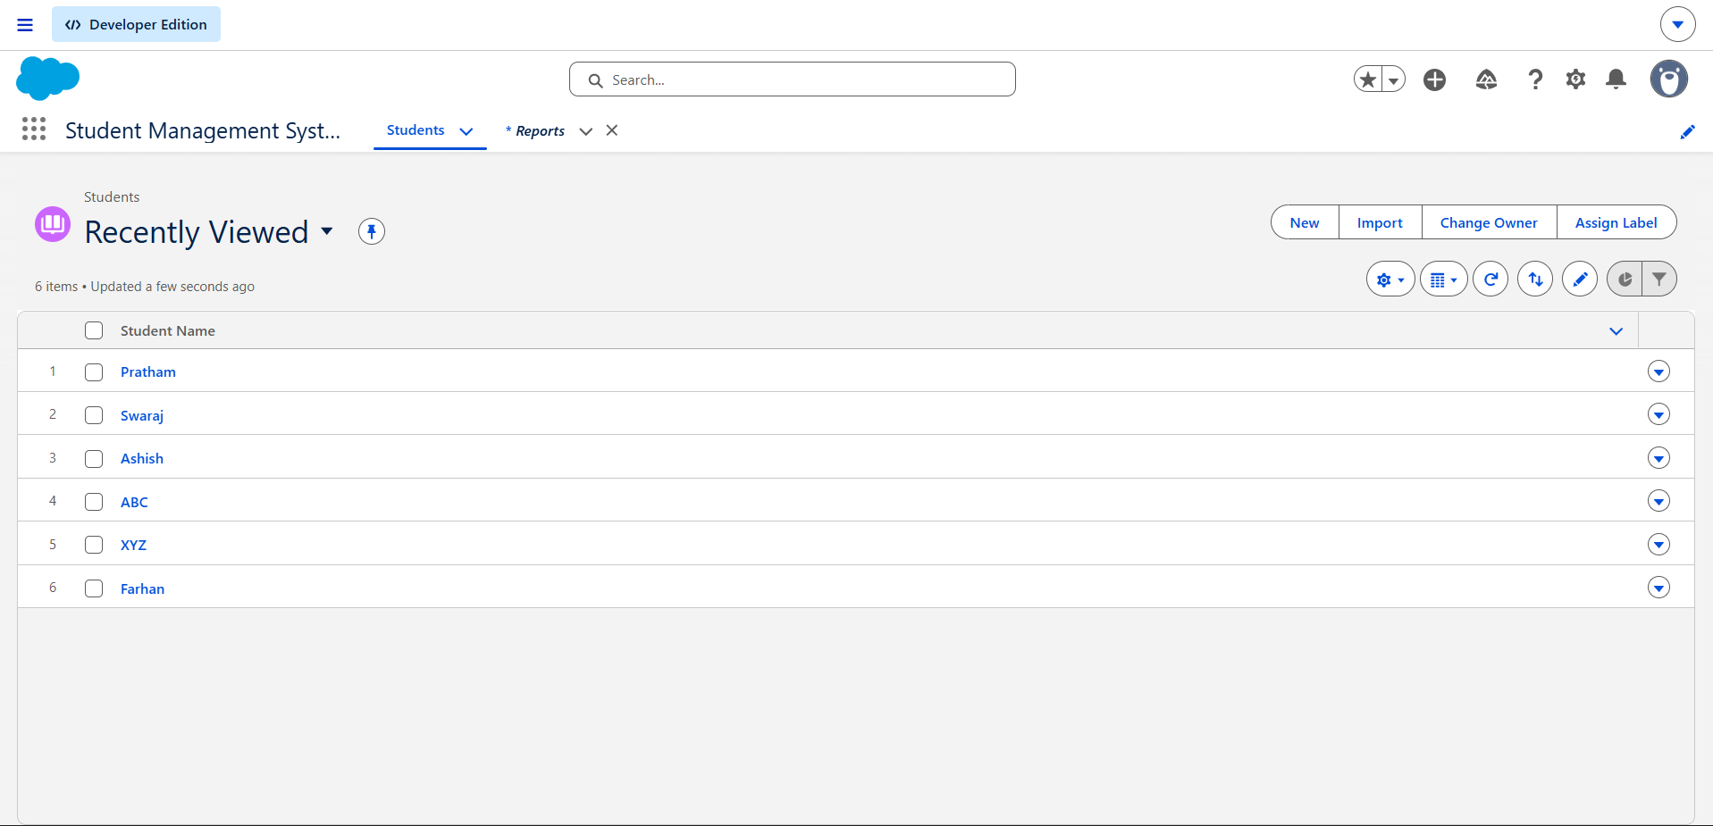
Fig 7: Students List View (Records Displayed)
Step 8 : Applying Validation Rules
Age Validation Rule
- Condition: Age < 18
- Error: Student must be at least 18 years old
Phone Validation Rule
- Condition: Only 10 digits allowed
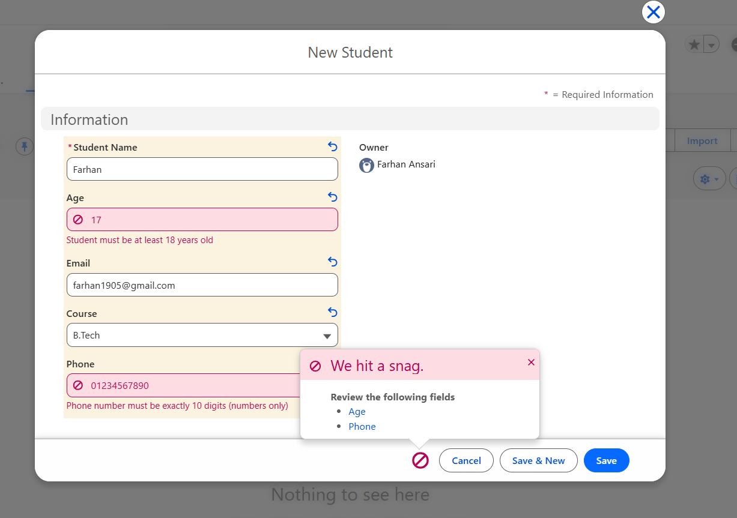
Fig 8: Age and Phone Validation Rule Configuration

Step 9: Creating Report and Chart
- Create report using Student object
- Add chart to report
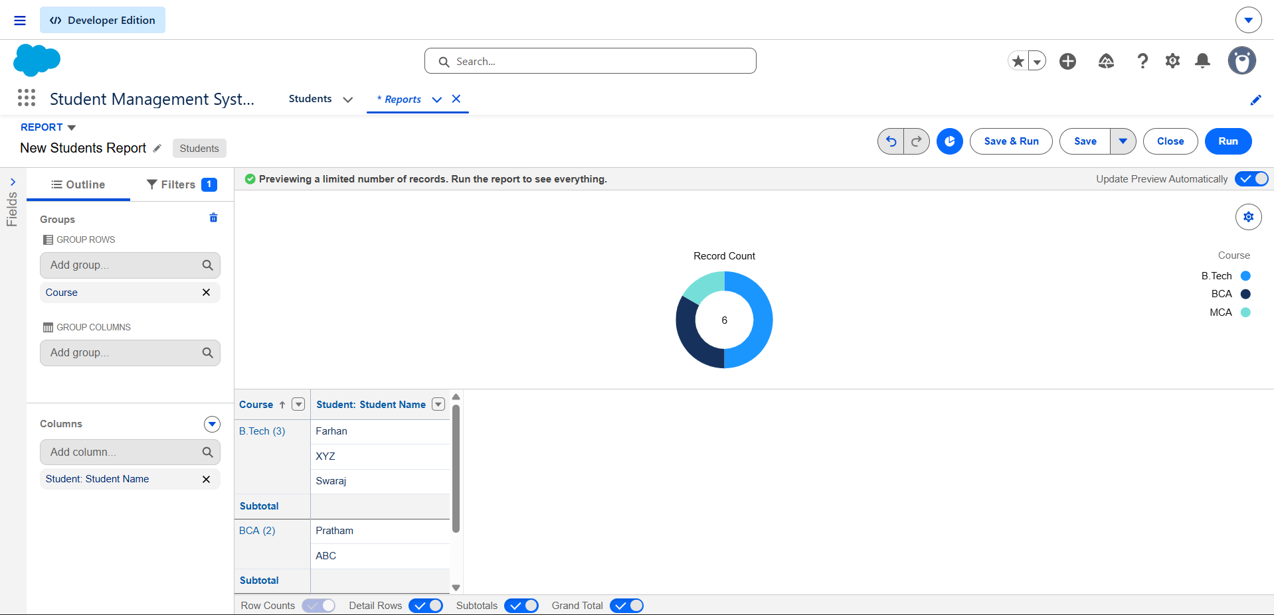
^{Fig 9: Chart Visualization}

Observations
- Custom object created successfully
- Fields added correctly
- Validation rules working properly
- Records stored successfully
- Report generated with data

Advantages
- Easy to use platform
- No coding required
- Data validation improves accuracy
- Reports help in analysis

Limitations
- Requires internet connectivity
- Limited customization without coding
- Learning curve for beginners

Conclusion
In this practical, we successfully created a Student Management System using Salesforce. We implemented object creation, field management, validation rules, and reporting. This provided hands-on experience in building real-world CRM applications.

